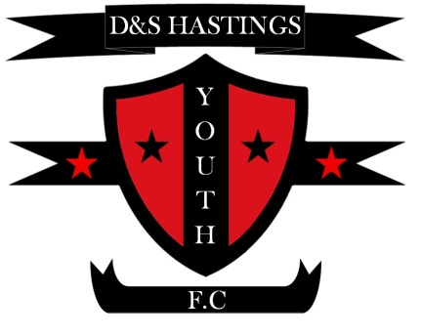
D & S Hastings Youth F.C Player Registration 2022-2023

Fan Number: (If Known)...........................................................................................................................
Team Name: (Age Group)........................................................................................................................
Player Name: ...................................................................................................................................

Address: ...................................................................................................................................................

Date Of Birth: ..........................................................................................................................................

Telephone Number: ................................................................................................................................

Email: .......................................................................................................................................................

Mobile No: ...............................................................................................................................................

Parent /Guardian (s)
Names: .....................................................................................................................................................

Alternative Contact Number In An Emergency: .....................................................................................

Medical Conditions (Must Be Informed): ...............................................................................................

I hereby wish to register as a member of D & S Hastings's youth F.C
The Registration fee: 7 and up: £30.00,
Adults : £50.00
Little kickers (2-6 year olds): £25.00
I have read the clubs code of conduct and agree to abide by it at all times as a spectator.
I will endeavour to enusre my Son/Daughter also abides by it at all times as a player.

Player Signature: ................................ Date: .............................................

Parent/Guardian Name: ..................................Signature: ....................................Date: ...................
Bank account Details :
Account Name: D and S Hastings Youth .FC
Account Sort Code: 04-06-05
Account Number: 15386294
Bank Name: Tide/Clear Bank
* Please put your child’s name as a reference

GDPR & Photograph Consent
Team photographs are occasionally posted onto the clubs website and social media pages.
From time to time they might be in football brochures.
If you do not wish for your child to be included in any of these platforms please sign here and cross out the above...........................................................................................................................
D & S Hastings will be contacting you for up and coming events and club news that may affect your Childs team and we will be mailing you.
As part of GDPR, The information that you provide us with is for our internal information only.
It helps us to understand our footballer’s needs. None of this will ever be passed on to others.
It may be used to communicate promotions to you.
If you do not want to be sent emails please sign here.......................................................................

Parents Contact Information that the F.A now require, (please fill in the form in capitals)
Parents Full Name: ...........................................................................................................................
Parents D.O.B: .................................................................................................................................
Parents Email: ..................................................................................................................................
Parents Contact No: .........................................................................................................................

Chairman &Treasurer: Stelios Michael
chairman@dandshastingsyouth.football

Secretary/Head Coach: Mel Saunters
Secretary@dandshastingsyouth.football

